RECIPES

That includes Cashew Nuts

AFIA FAHMIDA

aust,  Tejgaon, Love Road.

Contents

Intro 2

Ingredients of meat marinate: 3

Other ingredients: 4

Method……………...…………………………...5

***CHASHEW NUT SALAD RECIPE***

# Intro

Like a restaurant, you can make delicious Cashew Nut salad at home. Children will love to eat this item too.

*So, what are you waiting for? Let’s learn how to make this.*

## Ingredients of meat marinate:

|  |  |  |
| --- | --- | --- |
| Ingredients | | Amount |
| Chicken meat | 300 grams | |
|  | | Or 2 tsp |
| Salt | | as your taste |
| Pepper powder | | 1/4 tsp |
| Coriander powder | | 1 teaspoon |
| Ginger-Garlic mixture | | 2 tsp |
| Soy sauce | | 1 teaspoon |
| Corn Starch | | 3 tbsp |
| Lemon juice | | 1 tbsp |

  

 

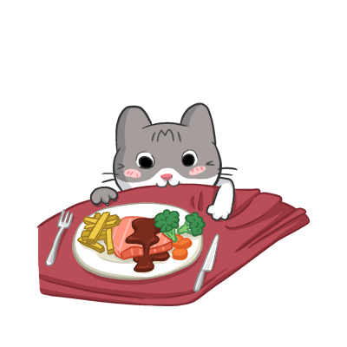

### Other ingredients:

|  |  |  |  |
| --- | --- | --- | --- |
| Ingredients | Amount | Ingredients | Amount |
| Oil | 1 cup | Sugar | 1 teaspoon |
| Cashew nuts | 1 cup | Sausages | 1 tbsp |
| Sesame seeds | 1 tbsp | Red and green capsicum | 3 cups |
| Chili Flakes | 1 tsp | Onion pieces | one and a half cups |
| Wester sauce | 1 tbsp | Mushroom | 1 cup |
| Tomato sauce | 2 tbsp | Carrot cookie | 1 cup |

#### Method:

To make Cashew Nut Salad, first, crush the chicken into small pieces. Wash, rinse with water and cover with marinade ingredients for 5 minutes. Heat the oil in a pan and sprinkle the spicy meat. Do not tighten the excess wedge. The inside should be soft. Pick up a piece of meat from the oil and serve it with cashew nuts in the same oil. When the nuts start to change color, pick them up and give them chili flakes and sesame oil.

Now reduce the fuel and whisk it together with tomato sauce, sugar and soy sauce. Bake for 20 seconds, mixing 2 tablespoons of water. Once the sauce is made, close the oven and place it in the pan with the almonds and meat pieces kept in the pan. Serve nicely with slices of capsicum, onion, mushrooms, and carrots.

THE END